ASSEMBLY INSTRUCTIONS BESAFE-SCREEN

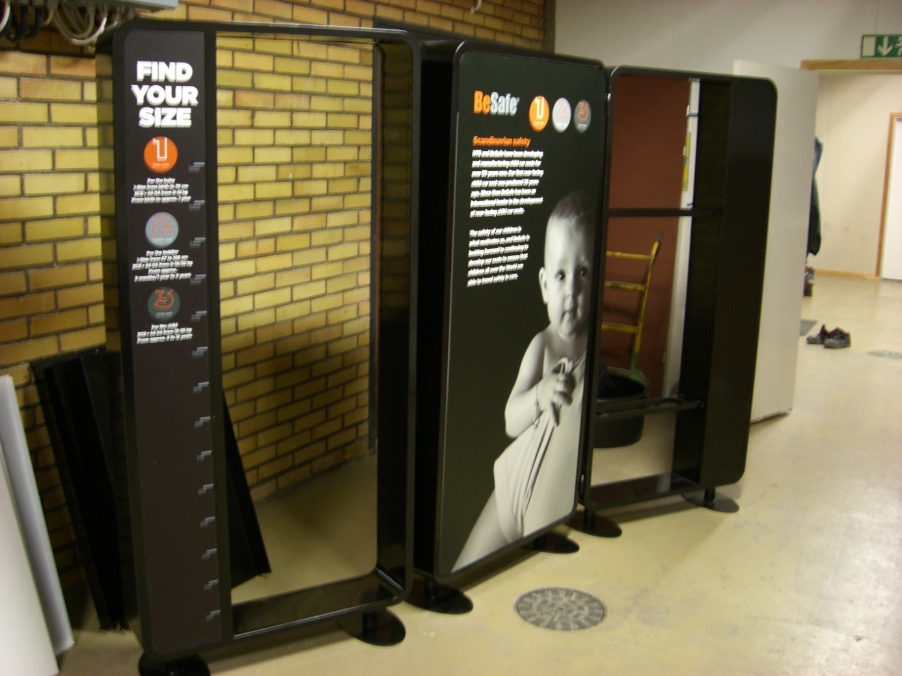

CONTENT PACKAGE 1

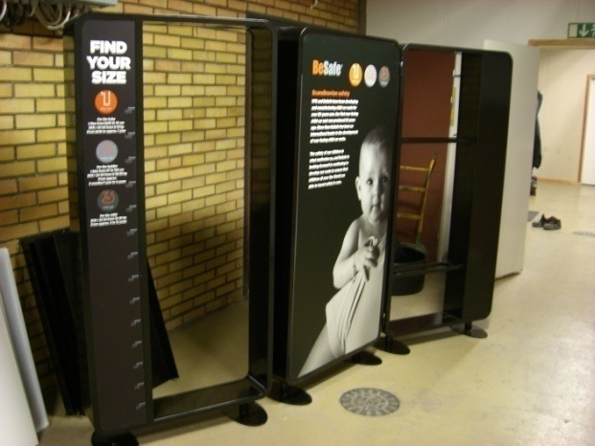 | 3 modules

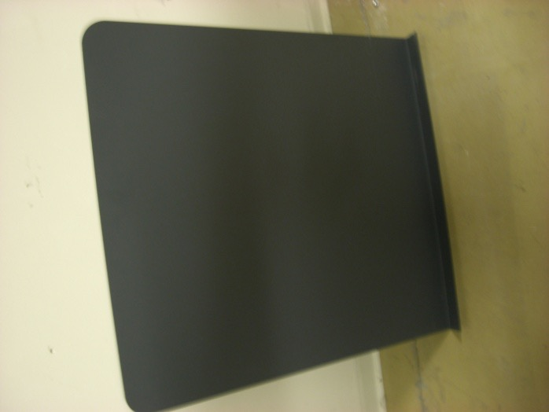 | 2 shelves
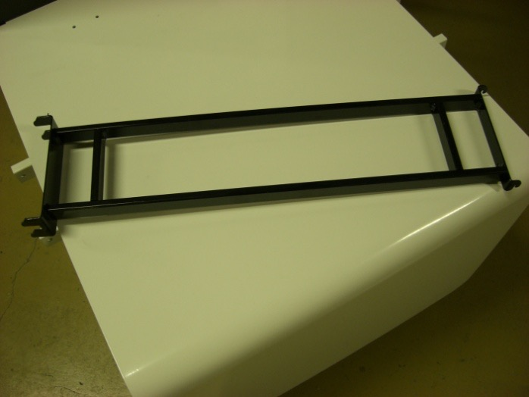 | 2 brackets for shelves
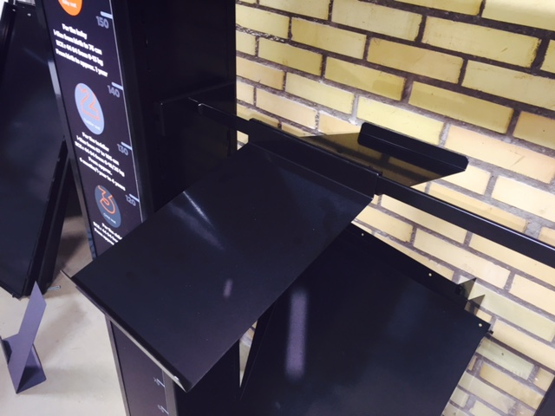  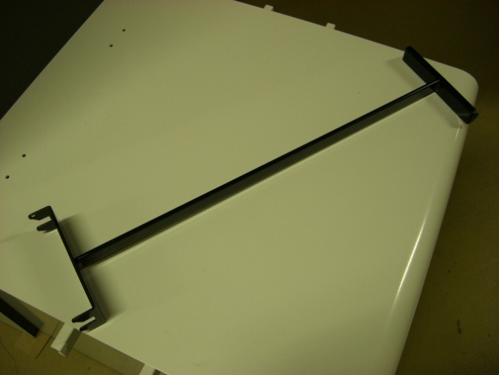 | 1 shelf for product information  4 brackets for accessory holders
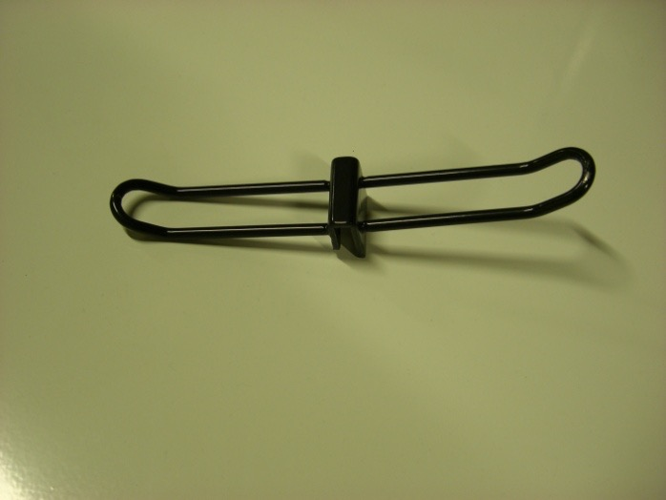 | 10 double sided accessory holders 27mm  1 single sided accessory holder 20mm
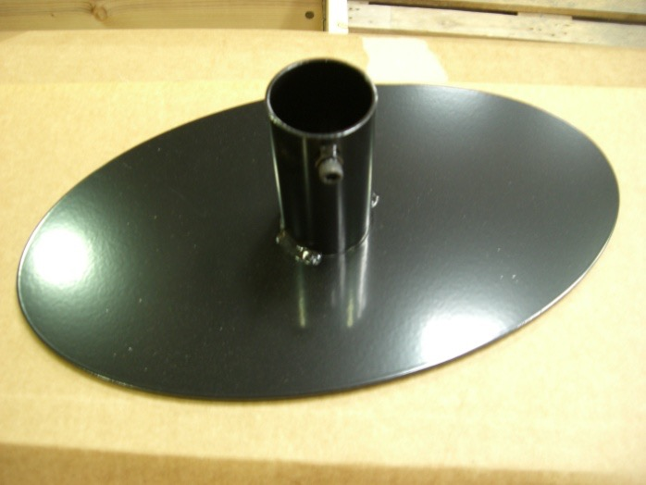 | 6 module feet
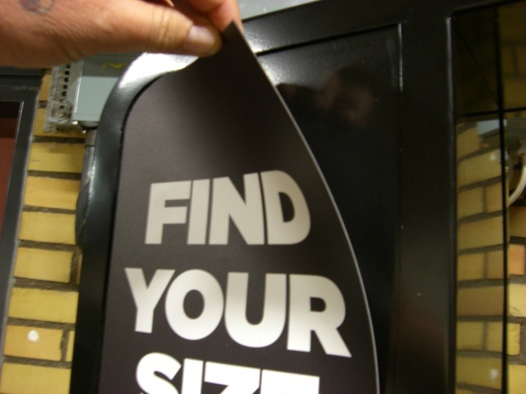 | 4 graphic magnet vinyls
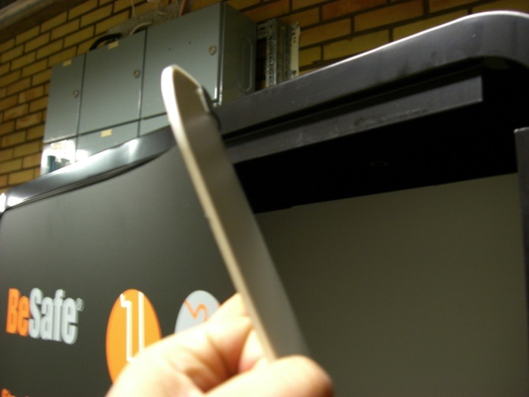 | 2 graphic posters

 | 1 detachable logo

Protective gloves
2 data label holders
12 plastic podium halves, 24 mounting rails
3 podium cover plates
3 plastic product information holders
Assembly instructions

ASSEMBLY ADVICE
Please use the protective gloves during assembly to avoid cuts and fingerprints on the details.
Two people are needed for assembly.
Recommended tools: 3mm 6mm wrench / unbrako

MONTERING
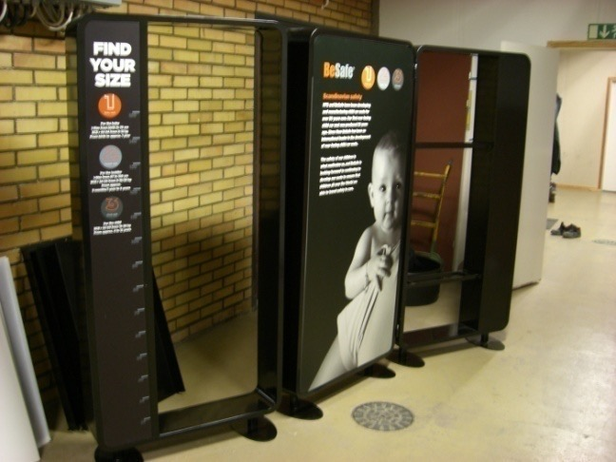 | 1 Place the three modules on a dry, dust-free surface. Loosen the bolts on the feet and assemble them onto the modules. Tightenthe bolts.  2 Lift the modules and place them in an approx 30° angle relative to each other.

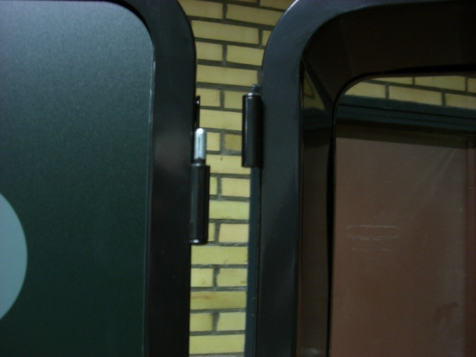 | 3 Fit the left and right module’s hinges onto oneanother

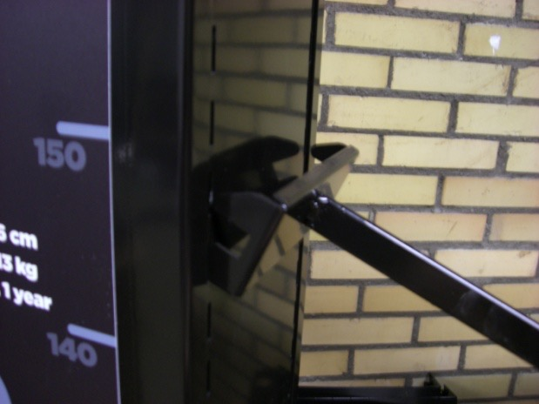 | 4 Fit the bracket for the double sided accessory holder on to the right module.

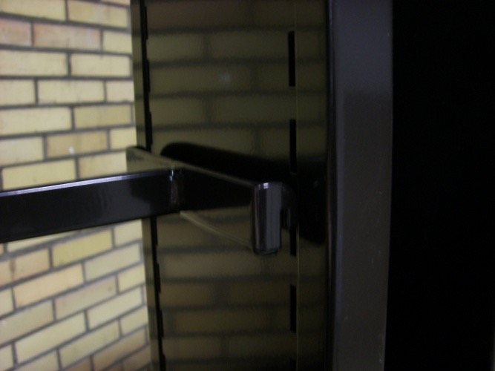 | 5 Fit the bracket into the holes on the right side.

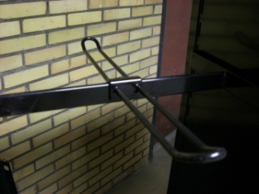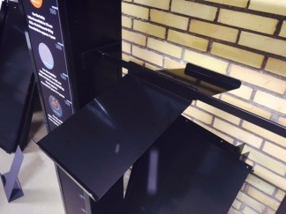 | 6 Assemble double sided accessory holder and shelf by pushing them down on the bracket.

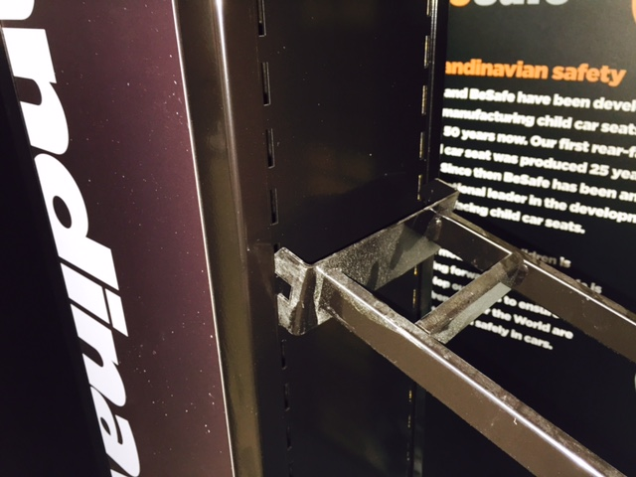 | 7 Hold the right side of the bracket towards the module and push the left side down to fit.

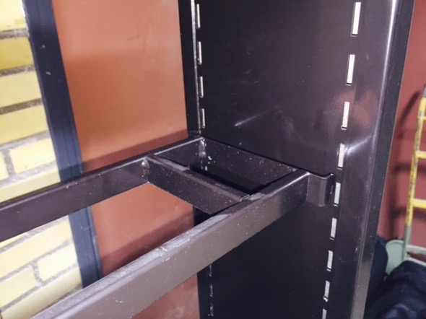 | 8 Push the right side of the bracket into the holes to fit.

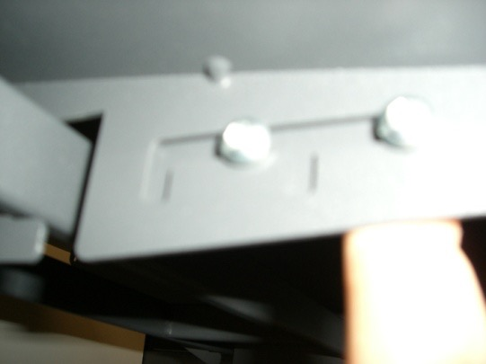 | 9 Assemble the shelves on the left module.  The shelves have a locking mechanism that should be pushed up and back before fitting the shelves on to the bracket.

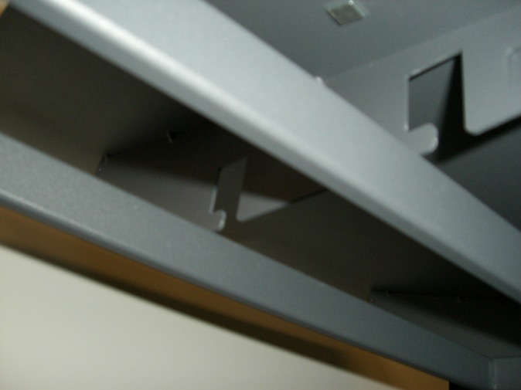 | 10 Fit the shelf on to the bracket, and push it back until it stops.

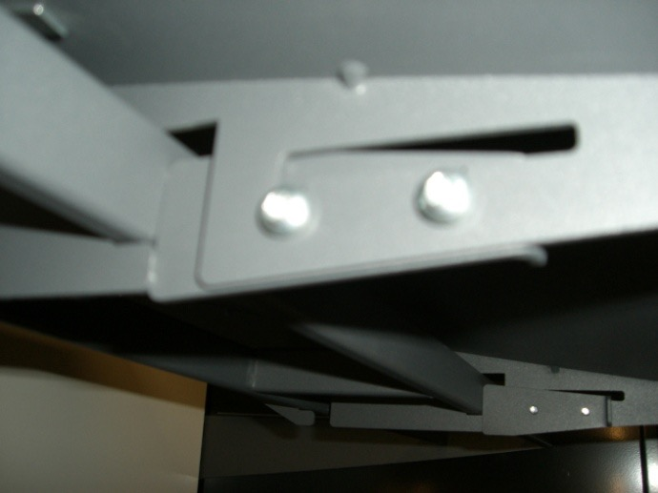 | 11 When the shelf is in place, push the locking mechanism forward and down. Make sure the shelf is properly fastened.  Fit the data label holder on the front of the shelf. You might need to adjust the length using scissors.

 | 12 Assemble the BeSafe logo on top of the mid module.  

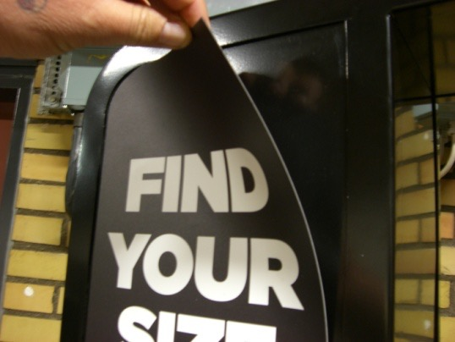  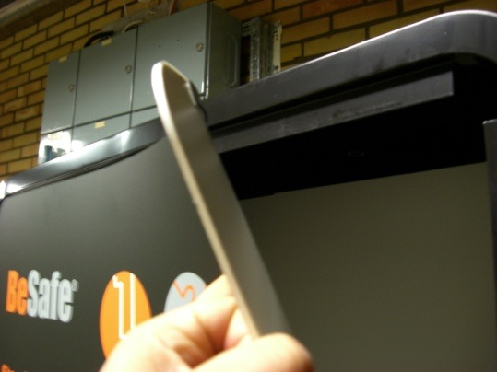 | 13 Fit the four magnet vinyls on to the modules. Start in the one end and adjust the height and side.  Finish by fitting the posters on the mid module.  The assembly of the screen module is now complete.

PODIUM ASSEMBLY

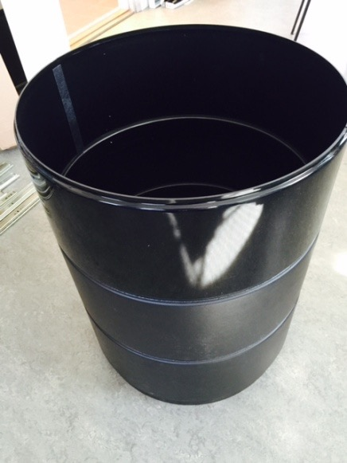

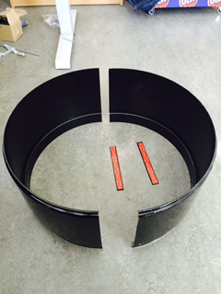 | The podiums consists of two halves and mounting rails with double sided tape.

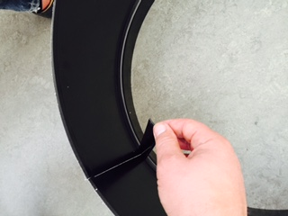 | Carefully press the halves together. Make sure there are no gaps between the two halves.  Take off the protection film on the tape and place the rail on the inside of the halves. Push the rail down with both hands on each side of the podium.

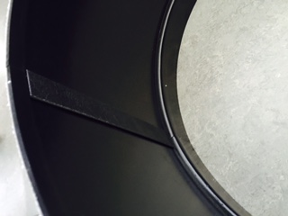 | Repeat the process on the other side.

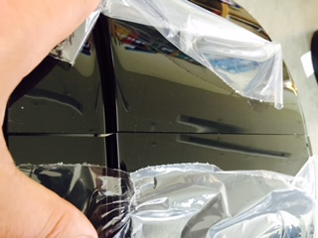 | Remove the protective film.

The podiums shall be placed three and two on top of one another. Continue to place the cover plates on the podiums and product information holders. The pockets for product information should be assembled on the product information holder.

